LAB 9 - Graph Traversals: BFS and DFS
Data Structures and Algorithms Laboratory

Student Details
Name | Pratyush Deo Singh
Registration Number | 25BCE5101
Semester | 2nd
Subject | Data Structures and Algorithms
Slot | A2
Faculty Name | Dr. Malini A

Programs

Program 1: Graph BFS using Adjacency List

File Name:
q1_bfs_adjacency_list.c

Program Code:
#include <stdio.h>
#include <stdlib.h>
#define MAX 100
struct Node {
int vertex;
struct Node* next;
};
struct Node* adjList[MAX];
int visited[MAX];
int queue[MAX];
int front = 0, rear = 0;
struct Node* createNode(int v) {
struct Node* newNode = (struct Node*)malloc(sizeof(struct Node));
newNode->vertex = v;
newNode->next = NULL;
return newNode;
}
void addEdge(int src, int dest) {
struct Node* newNode = createNode(dest);
newNode->next = adjList[src];
adjList[src] = newNode;
newNode = createNode(src);
newNode->next = adjList[dest];
adjList[dest] = newNode;
}
void enqueue(int v) {
queue[rear++] = v;
}
int dequeue() {
return queue[front++];
}
int isEmpty() {
return front == rear;
}
void bfs(int start) {
visited[start] = 1;
enqueue(start);
printf("BFS Traversal Order: ");
while (!isEmpty()) {
int current = dequeue();
printf("%d ", current);
struct Node* temp = adjList[current];
while (temp != NULL) {
if (!visited[temp->vertex]) {
visited[temp->vertex] = 1;
enqueue(temp->vertex);
}
temp = temp->next;
}
}
printf("\n");
}
int main() {
int vertices, edges, src, u, v;
printf("Enter number of vertices: ");
scanf("%d", &vertices);
printf("Enter number of edges: ");
scanf("%d", &edges);
for (int i = 0; i < vertices; i++) {
adjList[i] = NULL;
visited[i] = 0;
}
printf("Enter edges (u v):\n");
for (int i = 0; i < edges; i++) {
scanf("%d %d", &u, &v);
addEdge(u, v);
}
printf("Enter source vertex: ");
scanf("%d", &src);
bfs(src);
return 0;
}

Sample Test Input:
Enter number of vertices: 5
Enter number of edges: 5
Enter edges (u v):
0 1
0 2
1 3
1 4
2 4
Enter source vertex: 0

Expected Output:
BFS Traversal Order: 0 2 1 4 3

Output Screenshot:
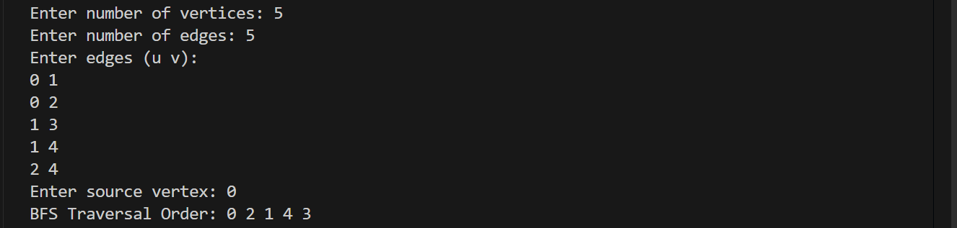

Program 2: Graph DFS using Adjacency Matrix

File Name:
q2_dfs_adjacency_matrix.c

Program Code:
#include <stdio.h>
#define MAX 100
int adjMatrix[MAX][MAX];
int visited[MAX];
int vertices;
void addEdge(int u, int v) {
adjMatrix[u][v] = 1;
adjMatrix[v][u] = 1;
}
void dfs(int src) {
visited[src] = 1;
printf("%d ", src);
for (int i = 0; i < vertices; i++) {
if (adjMatrix[src][i] == 1 && !visited[i]) {
dfs(i);
}
}
}
int main() {
int edges, u, v, src;
printf("Enter number of vertices: ");
scanf("%d", &vertices);
printf("Enter number of edges: ");
scanf("%d", &edges);
for (int i = 0; i < vertices; i++) {
visited[i] = 0;
for (int j = 0; j < vertices; j++) {
adjMatrix[i][j] = 0;
}
}
printf("Enter edges (u v):\n");
for (int i = 0; i < edges; i++) {
scanf("%d %d", &u, &v);
addEdge(u, v);
}
printf("Enter source vertex: ");
scanf("%d", &src);
printf("DFS Traversal Order: ");
dfs(src);
printf("\n");
return 0;
}

Sample Test Input:
Enter number of vertices: 5
Enter number of edges: 5
Enter edges (u v):
0 1
0 2
1 3
1 4
2 4
Enter source vertex: 0

Expected Output:
DFS Traversal Order: 0 1 3 4 2

Output Screenshot:
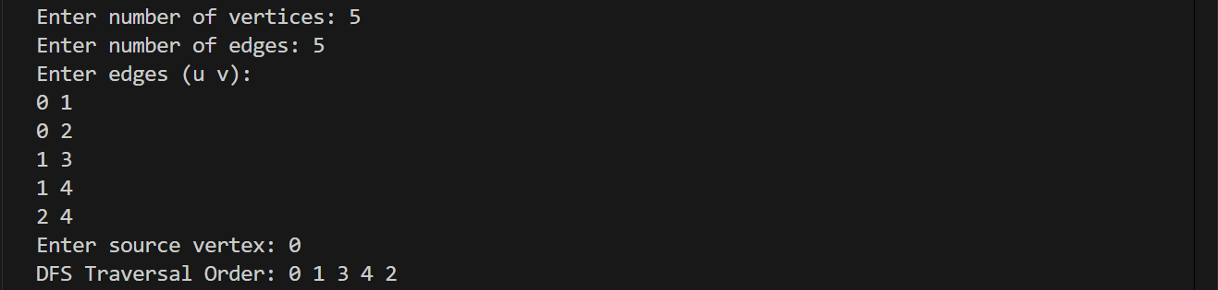

Program 3: DFS using Stack Implementation

File Name:
q3_dfs_stack.c

Program Code:
#include <stdio.h>
#include <stdlib.h>
#define MAX 100
struct Node {
int vertex;
struct Node* next;
};
struct Node* adjList[MAX];
int visited[MAX];
int stack[MAX];
int top = -1;
struct Node* createNode(int v) {
struct Node* newNode = (struct Node*)malloc(sizeof(struct Node));
newNode->vertex = v;
newNode->next = NULL;
return newNode;
}
void addEdge(int src, int dest) {
struct Node* newNode = createNode(dest);
newNode->next = adjList[src];
adjList[src] = newNode;
newNode = createNode(src);
newNode->next = adjList[dest];
adjList[dest] = newNode;
}
void push(int v) {
stack[++top] = v;
}
int pop() {
return stack[top--];
}
int isEmpty() {
return top == -1;
}
void dfsStack(int start) {
push(start);
printf("DFS Traversal Order (Stack): ");
while (!isEmpty()) {
int current = pop();
if (visited[current])
continue;
visited[current] = 1;
printf("%d ", current);
struct Node* temp = adjList[current];
while (temp != NULL) {
if (!visited[temp->vertex]) {
push(temp->vertex);
}
temp = temp->next;
}
}
printf("\n");
}
int main() {
int vertices, edges, src, u, v;
printf("Enter number of vertices: ");
scanf("%d", &vertices);
printf("Enter number of edges: ");
scanf("%d", &edges);
for (int i = 0; i < vertices; i++) {
adjList[i] = NULL;
visited[i] = 0;
}
printf("Enter edges (u v):\n");
for (int i = 0; i < edges; i++) {
scanf("%d %d", &u, &v);
addEdge(u, v);
}
printf("Enter source vertex: ");
scanf("%d", &src);
dfsStack(src);
return 0;
}

Sample Test Input:
Enter number of vertices: 5
Enter number of edges: 5
Enter edges (u v):
0 1
0 2
1 3
1 4
2 4
Enter source vertex: 0

Expected Output:
DFS Traversal Order (Stack): 0 2 4 1 3

Output Screenshot:
